Test Case: tc006_SPX_Dev5_Crear_Requisicion_Spot_Tipo_Cobro_Proyect_Urgent
Step 1 - Enter username and password and click to button Enter: Credentials Entered
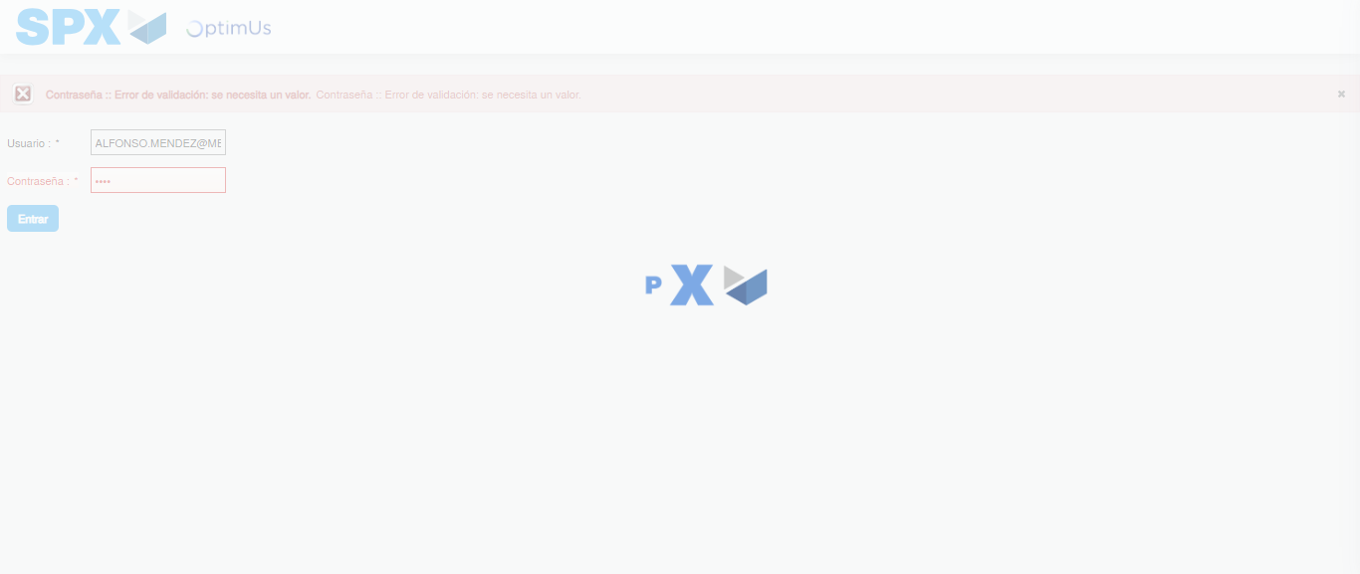Image file-name: QC_Testing-tc006_SPX_Dev5_Crear_Requisicion_Spot_Tipo_Cobro_Proyect_Urgent-1783376673566

Step 2 - Select to UEN and Access to Spot Buy Requisitions : UEN Correctly selected and Correct access
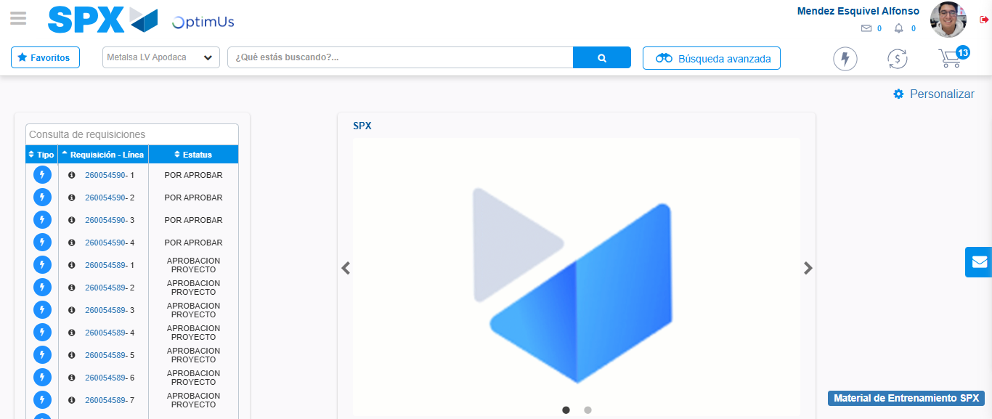Image file-name: QC_Testing-tc006_SPX_Dev5_Crear_Requisicion_Spot_Tipo_Cobro_Proyect_Urgent-1783376699391

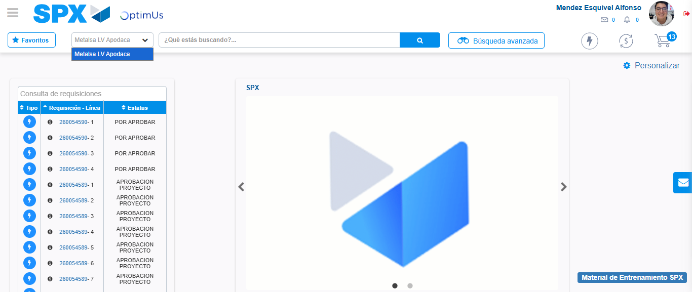Image file-name: QC_Testing-tc006_SPX_Dev5_Crear_Requisicion_Spot_Tipo_Cobro_Proyect_Urgent-1783376701903

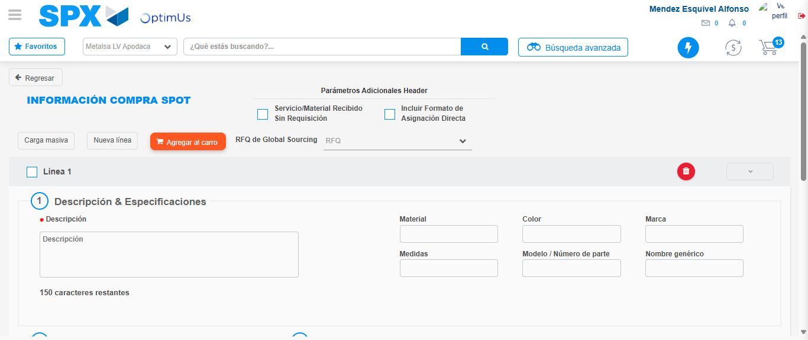Image file-name: QC_Testing-tc006_SPX_Dev5_Crear_Requisicion_Spot_Tipo_Cobro_Proyect_Urgent-1783376724828

Step 3 - Data Capture Spot Buy Requisition: Data captured correctly
Image file-name: QC_Testing-tc006_SPX_Dev5_Crear_Requisicion_Spot_Tipo_Cobro_Proyect_Urgent-1783376725036

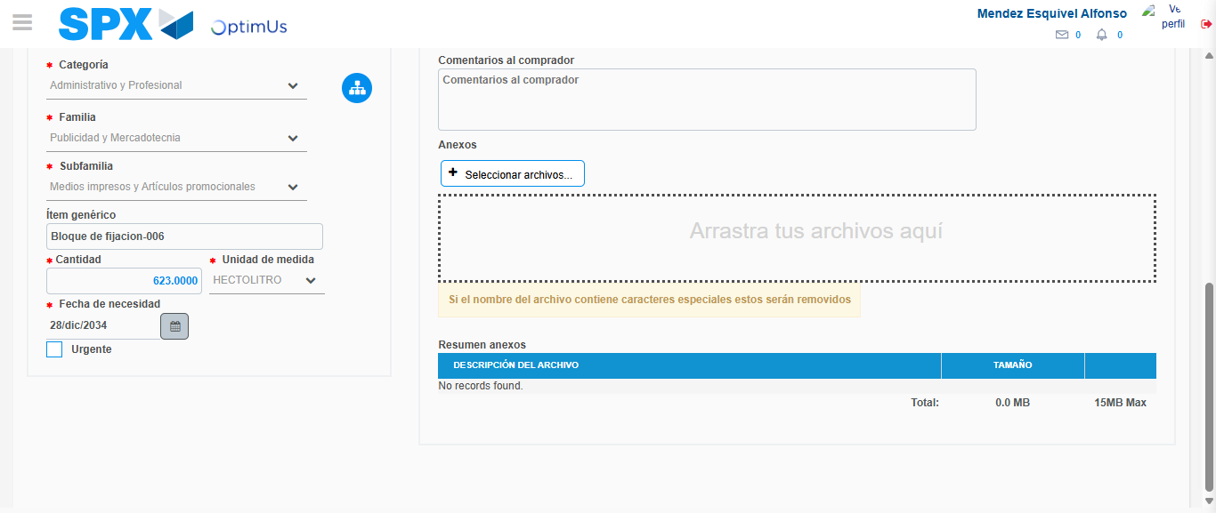Image file-name: QC_Testing-tc006_SPX_Dev5_Crear_Requisicion_Spot_Tipo_Cobro_Proyect_Urgent-1783376735118

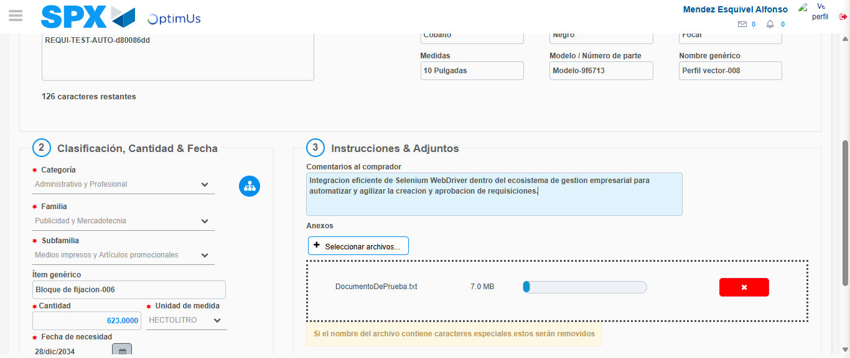Image file-name: QC_Testing-tc006_SPX_Dev5_Crear_Requisicion_Spot_Tipo_Cobro_Proyect_Urgent-1783376735904

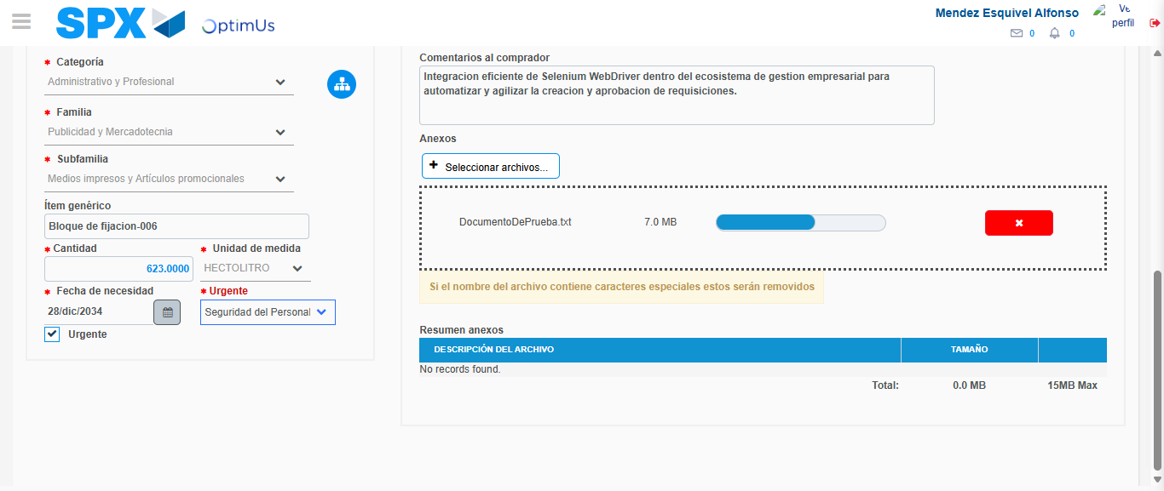Image file-name: QC_Testing-tc006_SPX_Dev5_Crear_Requisicion_Spot_Tipo_Cobro_Proyect_Urgent-1783376739597

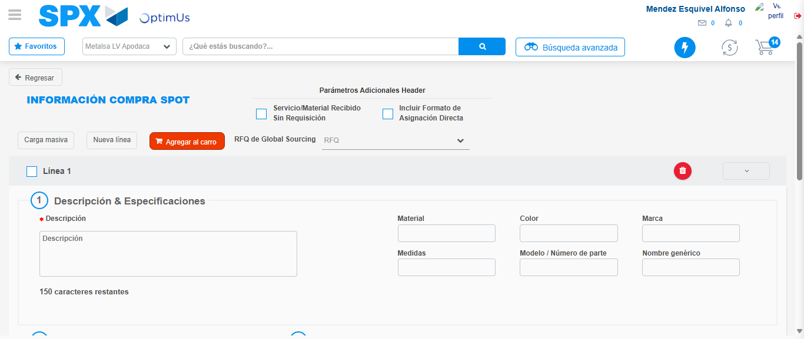Image file-name: QC_Testing-tc006_SPX_Dev5_Crear_Requisicion_Spot_Tipo_Cobro_Proyect_Urgent-1783376744487

Step 7 - Return to Main Page SPX : Return to Main Page SPX
Image file-name: QC_Testing-tc006_SPX_Dev5_Crear_Requisicion_Spot_Tipo_Cobro_Proyect_Urgent-1783376699391

Image file-name: QC_Testing-tc006_SPX_Dev5_Crear_Requisicion_Spot_Tipo_Cobro_Proyect_Urgent-1783376701903

Image file-name: QC_Testing-tc006_SPX_Dev5_Crear_Requisicion_Spot_Tipo_Cobro_Proyect_Urgent-1783376724828

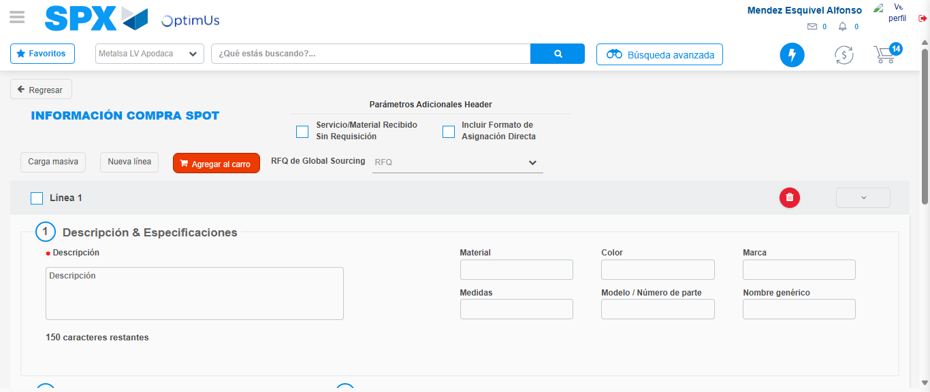Image file-name: QC_Testing-tc006_SPX_Dev5_Crear_Requisicion_Spot_Tipo_Cobro_Proyect_Urgent-1783376747248

Image file-name: QC_Testing-tc006_SPX_Dev5_Crear_Requisicion_Spot_Tipo_Cobro_Proyect_Urgent-1783376747434

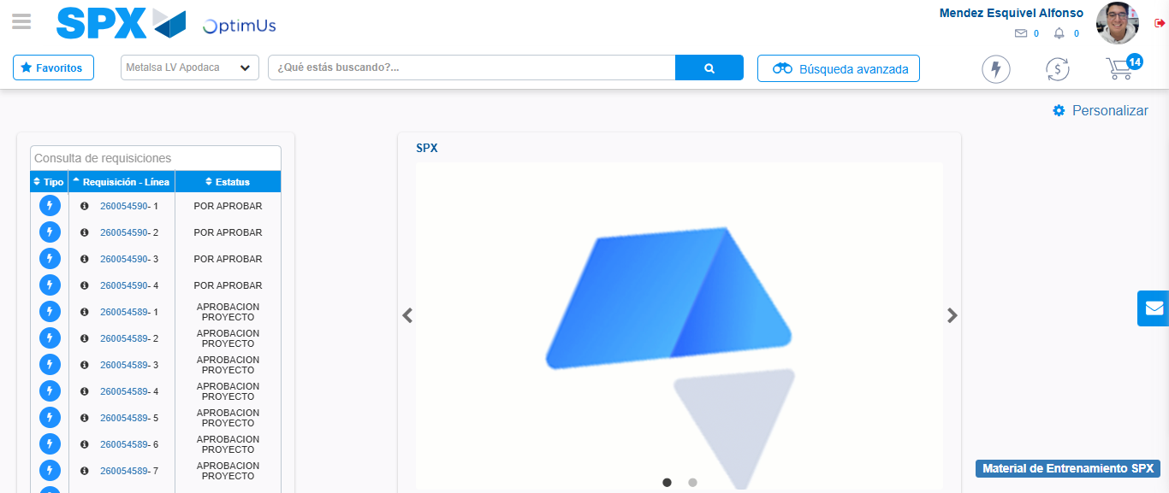Image file-name: QC_Testing-tc006_SPX_Dev5_Crear_Requisicion_Spot_Tipo_Cobro_Proyect_Urgent-1783376768643

Step 8 - Log Out : Log Out SPX
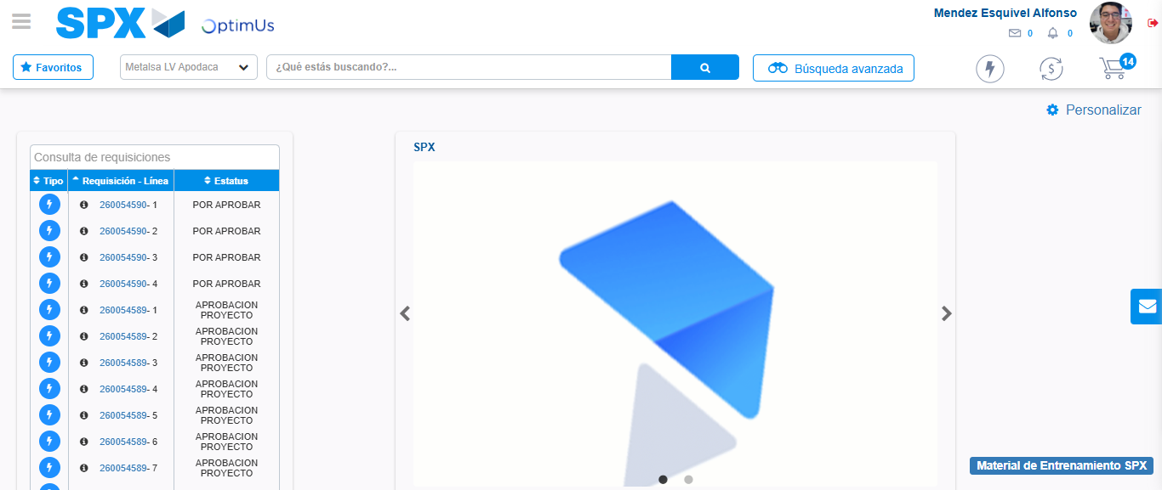Image file-name: QC_Testing-tc006_SPX_Dev5_Crear_Requisicion_Spot_Tipo_Cobro_Proyect_Urgent-1783376768894

